 | 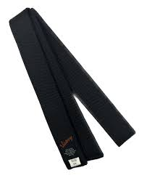
Black Stripe to Black Belt

Courtesy, Integrity, Indomitable spirit, Perseverance, Self control
Code of Conduct:
Bowing to Master & Instructor and Senior belts (Black belts)
Calling Master & Instructor as Sir
Bowing to Training place (Dojang) while entering and leaving
Bowing to other members and shaking hands
The chart below is only a guideline and you need to meet the instructor’s expectations to pass the grading.

