 | 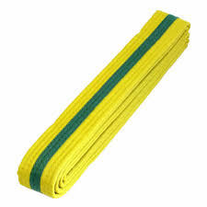

Yellow Belt to Green Stripe

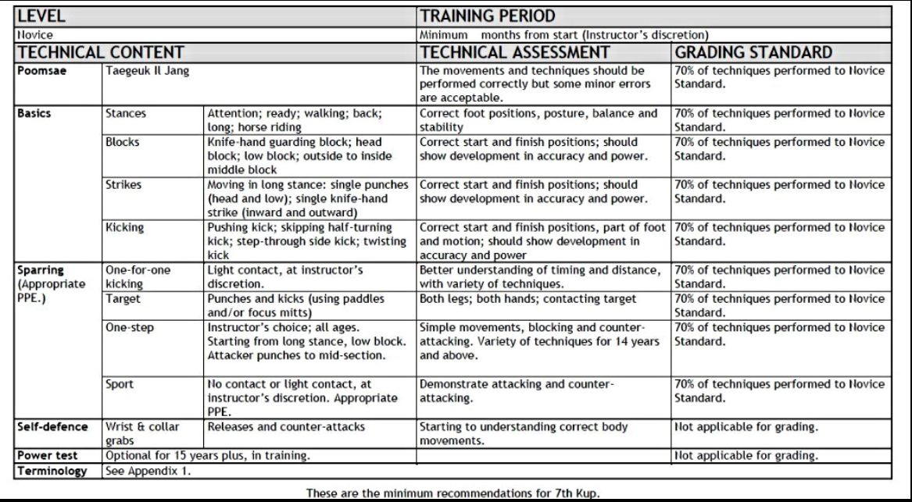

Single Knife hand outward block Video
Taekwondo single Knife hand outward block - Hansonnal-bakkat-makgi

