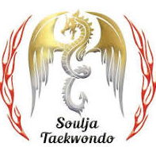 | 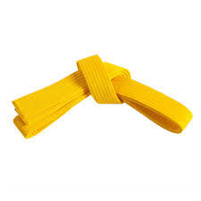
Yellow Stripe to Full Yellow Belt

Basics:
Stances: Attention; ready; walking; back; long; horse riding
Blocks: Low Block; Middle section block; High block; Guarding block

Strikes:
Moving in long stance: single punch
Horse riding stance: Double and triple punches
Kicking: Side Kick; Axe kick
Sparring:
One for one kicking (No contact)
Light or no contact

Pattern(Poomsae): Instructor's discretion
Target:
Punches and kicks(Paddles and focus mitts)
One- Step:
For 14 years old and above
Self-defence: Wrist & collar grabs
Power test: Instructor's discretion
Terminology:
Attention: Charyot
Ready: Joonbi
Bow: Kyong ye
Stance: Sogi
Front stance: Ap sogi
Long stance: Apkoobi sogi
Back stance: Dwitkoobi sogi
Horse riding stance: Joochoom sogi
Block: Makki
Low block: Arae Makki
Middle block: Momtong Makki
High (head) block: Ulgol Makki
Guarding block: Goduro Makki
Kick: Chagi
Front kick: Ap chagi
Crescent kick (outside to inside and inside to outside): An Chagi / bakat chagi
Side kick: Yop chagi
Axe kick (Chop kick):
Chiko Chagi (Naeryo chagi)

Outside middle block video
Taekwondo Outside Middle Block - Momtong-bakkat-makgi

